SableSpecimen Project Outline and Documentation
By: Andrew Dimond
Last Updated: 1/20/26

Introduction:
SableSpecimen is a python application developed for use on the Alaska Fisheries Science Center’s annual Longline survey executed by the Marine Ecology and Stock Assessment (MESA) program of Auke Bay labs (ABL). The purpose of this application is to digitize the data collected by scientists pulling otoliths and tagging specimens. It works by using several GUI windows to query, read, and write data from a simple Access database. This database is a simple hierarchical model with parent Event (Station/Haul) records having child Otolith Specimen and Tag Specimen records. Put another way, every otolith or tag specimen that has its data logged must be associated with a specific sampling event. This application should be lightweight in design so it can be effectively run on MESA’s rugged PC’s, which are relatively random-access memory (RAM) limited. This document will outline the python file structure and design, database design, and a basic walkthrough of the application.

Python File Structure and Design
The file structure of this application uses a tree structure wherein a main python file is used to launch the application and additional files control the launching and function of subsequent menus based on the inputs of the user. The tree below shows a basic outline of the current planned structure:
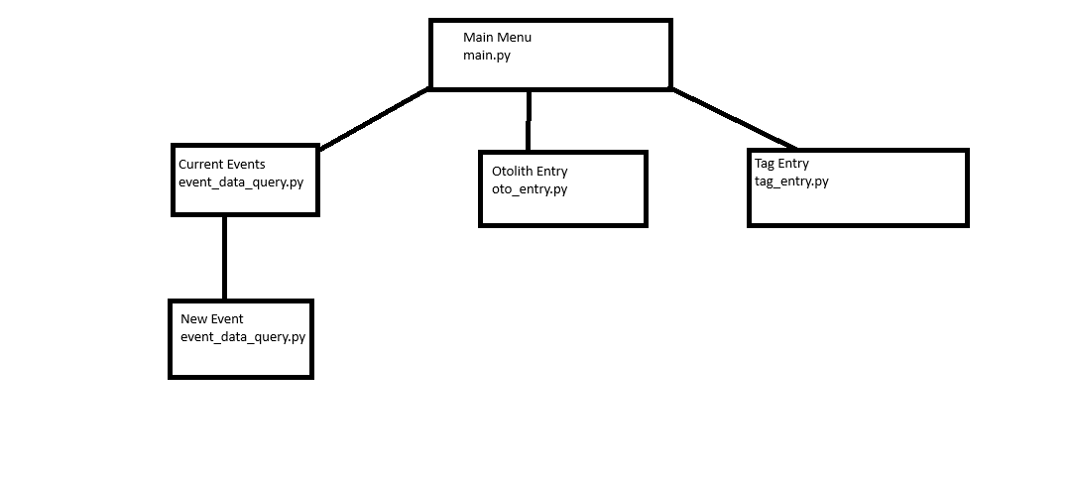

Python UI Files
This project uses PyQT5 for the design of all UI files. Each menu is designed in QTDesigner and has its python file generated for calling in associated python files that build menu functionality.

Python Packages
Current list of python packages used for the construction of this project:
Python 3.9.26
pyodbc
PyQt5
sys
All of these packages were managed via miniforge/conda with the exception of PyQt5 Tools (Qt Designer) as that is not available on the conda-forge channel and was instead installed via pip.
Folder Organization:
Each sub-menu is contained within its own respective folder. The Event Menu is stored within the Event_Select folder, the Otolith Specimen Entry is contained within the Otolith_entry folder, and the Tag Entry is stored within the Tag_Entry folder. All base UI files are stored within the ui folder, and all python generated UI files are stored there as well.

Database Design and Procedures
The database this application writes to is currently a Microsoft Access 365 database. The database directory is currently in the main folder of the project. Future consideration needs to be given about where this database is stored, as the code will need to point the application to the specific database in question. Likely, storing the database in the main program directory (within the main folder SableSpecimen) would work as all files will use the directory of the folder regardless of what device it is loaded onto (i.e. you wouldn’t have to edit the C:\users… String for each device you load this program onto.
Users will need to know where this database is located as they will need to manually back up the data from this database manually until such time as this application is

